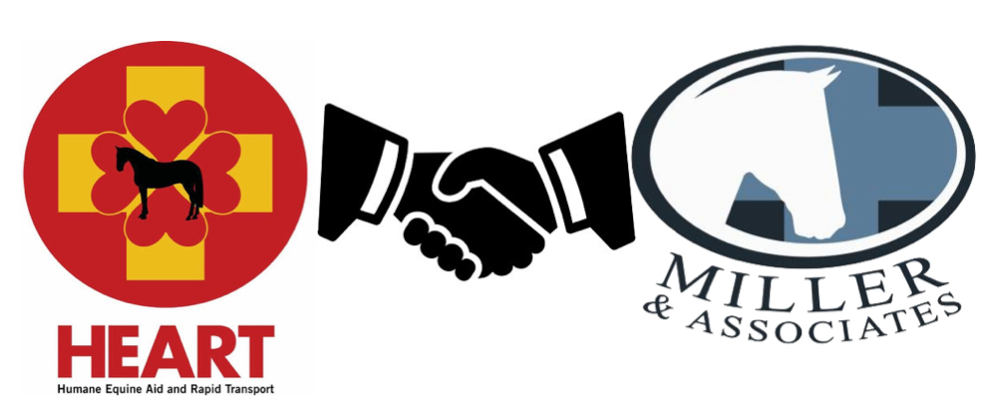

HEART Equine Ambulance is pleased to announce new corporate sponsor support from Miller & Associates.

Miller & Associates, DVM is a team of veterinarians committed to improving your horse's well being. Miller & Associates’ goal is to provide the most progressive, collaborative and compassionate care for every horse. "Miller & Associates and HEART share a common mission - to provide the highest standard of care for our competitive equine athletes. It is reassuring to know that HEART is available at so many events to assist our veterinarians in providing the timely and compassionate care our patients deserve." Dr. Christopher (Kit) Miller, DVM

HEART Board President Robin Sweely remarked, " We have been seeking corporate partners to help us continue to expand our mission of providing emergency transportation services for ill or injured horses at competitive events across the country. We are thrilled to have Miller & Associates partner with HEART to help us continue to grow and be able to provide our service to more events across the United States."

HEART’s goal is for every equine event to have a fully equipped and well-trained ambulance staff on site and available 24 hours a day. Each HEART staff member is trained by Technical Large Animal Emergency Rescue (TLAER), and they treat every situation they encounter with compassion and professionalism. If your event or show does not have an equine ambulance on site, make a plea to the horse show management. The safety and care of our equine partners is paramount. An equine ambulance should be as common as having a human ambulance on site.

Miller & Associates will also provide educational information at special tours of the HEART ambulance during three upcoming equine events:

Old Salem Farm Spring Horse Shows, May 11, Hampton Classic, August 26 and the American Gold Cup, September 14.
#millerhasheart

