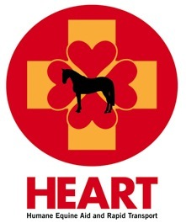

HEART Equine Ambulance
will benefit from Trivia Night
hosted by the Hampton Classic Horse Show

Join the Hampton Classic for Trivia Night, to benefit HEART Equine Ambulance, to be held at Marders (120 Snake Hollow Road in Bridgehampton) on Monday, June 17 from 6:30 to 8:30 p.m. The entrance fee is $40 and includes a light dinner and beverages.

Teams of 2-6 people will test their knowledge of general trivia topics in the beautiful Marders barn. Compete for the grand prize of an Opening Day VIP table for 8 (value: $400) in the USET Tent at the Hampton Classic on Sunday, August 25, and of course, bragging rights.

The $40 donation may be paid by check (payable to HEART) or by cash at the door. RSVP to reyna@hamptonclassic.com to guarantee your spot. Walk-ins will be accommodated as space is available.

Can't make it to Trivia Night but still want to donate to HEART? We appreciate your generosity. Donate today.

HEART provides state of the art emergency transportation services for injured or ill horses, at the Hampton Classic and other horse shows across the country, should the need arise. In addition, they offer programs aimed at educating the general public on standards of care for competition level horses. Every horse show is safer with their trained and certified ambulance attendants on the premises.

"Our goal at HEART is for every equine event to have a fully equipped and well-trained ambulance staff on site and available 24 hours a day. Each HEART staff member is trained by Technical Large Animal Emergency Rescue (TLAER), and they treat every situation they encounter with compassion and professionalism. If your event or show does not have an equine ambulance on site, make a plea to the horse show management. The safety and care of our equine partners is paramount. An equine ambulance should be as common as having a human ambulance on site." Robin Sweely, HEART Equine Ambulance Board President.

